Name: ______________________

Simulation: Ionic and Covalent Bonding
Background
In this investigation you will bond select atoms. Based upon the types of atoms that you choose to combine, you will create either an ionic compound or a covalent compound. You will have the opportunity to analyze the differences between these different types of compounds and to predict the number of atoms needed to create each, as well as learn how to appropriately name them.

- Describe the difference between an atom and a molecule:

- Where are metal atoms located on the periodic table? Where are non-metal atoms located on the periodic table?

- What subatomic particle(s) participate in chemical bonding?

- In your own words, define valence electron.

- How can you determine the number of valence electrons in an atom using the periodic table?

- Draw a Lewis Dot Structure for the following atoms:

- Strontium (Sr)
- Carbon (C)
- Iodine (I)
- Xenon (Xe)

*Check your answers before moving on to the next portion of the activity.
Procedure
Using your computer, tablet or mobile device, navigate to the website: http://www.teachchemistry.org/bonding. You should see the picture below on your screen.

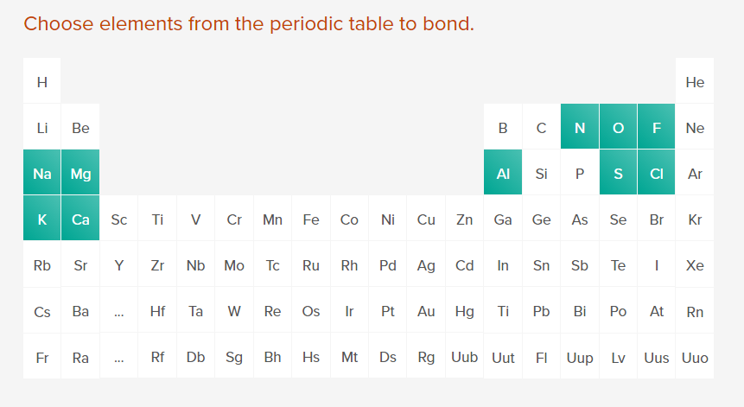

Part 1: Ionic Bonding
- Choose Sodium (Na).
  - What type of element is it?

  - How many valence electrons does it have?

- Choose Fluorine (F).
  - What type of element is it?

  - How many valence electrons does it have?

- Answer the question on the screen, “What type of bond is this combination likely to form?”

  - Circle: Ionic or Covalent?

  - Choose the appropriate number of atoms to make the bond. Record the number of each atom below:

- Watch the final animation closely (it will play continuously).
  - Describe the change in the number of valence electrons in the atoms as the bond is successfully formed:

  - What does the positive (+) charge indicate (mention specific subatomic particles in your answer)?

  - What does the negative (-) charge indicate (mention specific subatomic particles in your answer)?

  - What is the final overall charge?

  - Record the name and molecular formula for the compound below:

Reset the selected data using the reset symbol.

- Choose Calcium (Ca).
  - What type of element is it?

  - How many valence electrons does it have?

- Choose Chlorine (Cl).
  - What type of element is it?

  - How many valence electrons does it have?

- Answer the question on the screen, “What type of bond is this combination likely to form?”

  - Circle: Ionic or Covalent?

  - Choose the appropriate number of atoms to make the bond. Record the number of each atom below:

- Watch the final animation closely (it will play continuously).
  - Why were more than 2 total atoms needed to create this compound?

  - Explain what happened to the valence electrons in each atom.

  - What is the final overall charge?

  - Record the name and molecular formula for the compound below:

  - Have you noticed a pattern between the charge of the ion and the number of valence electrons it has? Explain how you can predict the charge based on the number of valence electrons, or the location of the element on the periodic table.

Reset the selected data using the reset symbol.

- Using a periodic table, complete the table below, then use the simulation to check each of your predictions:

Atom  #1 | Number of Valence Electrons | Prediction of charge | Atom  #2 | Number of Valence Electrons | Prediction of charge | Molecular Formula | Name of compound
Na |  |  | O
K |  |  | F
Mg |  |  | Cl
Ca |  |  | N
Al |  |  | S

Part 2: Covalent Bonding
- You will first investigate 5 diatomic molecules. Diatomic molecules are made up of 2 atoms.

- Select 2 fluorine atoms. How many valence electrons are in each fluorine atom?

- Is a fluorine atom a metal or a non-metal?

- Did the combination of these atoms create a covalent or ionic bond?

- How are the valence electrons organized to form a bond between these atoms?

- How is this different from the ionic bonds formed in the previous part of the activity?

- What shape does this molecule form?

- Select 2 oxygen atoms. How many valence electrons are in each oxygen atom?

- Is an oxygen atom a metal or a non-metal?

- Did the combination of these atoms create a covalent or ionic bond?

- How are the valence electrons organized to form a bond between the atoms?

- How is this bond different from the bond in the fluorine molecule in question 1?

- What shape does this molecule form?

- Make predictions in the following table. Once completed, check your answers using the simulation.
Lewis dot structure for single atom | Cl | S | N
Lewis dot structure for diatomic molecule
(Cl₂, S₂, N₂)

Molecular formula
Name of shape

- More than two atoms can also be combined to form a covalent molecule. These molecules may form different shapes and will also follow a particular naming system. Select the following combinations of atoms, and complete the rest of the table as you interact with the simulation:

1st atom choice | 2nd atom choice | Predict Formula | Molecular Name | Shape
S | F
N | Cl
Cl | F

Part 3: Critical thinking

- What are the differences between ionic and covalent bonds? Be sure to refer to valence electrons in your response.

- How is naming ionic and covalent compounds different? Use specific examples in your answer.

- Based on your knowledge of ionic and covalent bonds, complete the missing portions of the following table:

Name | Formula | Ionic or Covalent?
Beryllium bromide
 | PF₃
Sulfur diiodide
Strontium Phosphide
 | Cs₃N
 | H₂O

